Chapter 26
Incident command system and National Incident Management System
Sandy Bogucki and Kevin J. Schulz

Introduction
The operational effectiveness as well as the safety, or even survival, of all components of the local, regional, and state medical infrastructure confronted with a large-magnitude natural, manmade, or terrorism-related disaster will largely depend on the quality of the overall incident management. Public safety, public health, emergency management, and health care system officials should be familiar with the rudiments of emergency incident management theory and practice. Nowhere is this more important than in EMS, where the system must interface seamlessly with public safety entities that use the incident command system (ICS) for daily operations, and hospitals, where the administration typically alters its organizational management scheme to an ICS during major emergencies.
It is easy to understand why it is necessary to organize the management of emergency incidents differently than normal business or public administration plans. For example, a bureaucracy is, by definition, the wrong structure through which to manage a low-frequency, high-hazard incident. According to Webster’s Dictionary [1], a bureaucracy is a “government marked by diffusion of authority among numerous offices and adherence to inflexible rules of operation … [or] an administrative system in which the need to follow complex procedures impedes effective action.” In organizational theory, the core features of bureaucratic management include formalization (i.e. enforcement of rigid rules and procedures), specialization, and hierarchy [2]. This form of administration is most effective at handling large-volume, variably complex but routine tasks, in stable environments [3].
Management of unstable situations with potentially catastrophic outcomes requires establishment of high-reliability organizations [4]. Roberts et al. [5] observed that reliability is directly related to flexibility of the organizational structure. Temporary organizations assembled in response to specific challenges may provide such flexibility, and offer an attractive alternative to conventional structures that have not performed well in high-risk, high-hazard environments. Virtual organization represents an increasingly common temporary administrative architecture for corporate and public safety entities operating in crisis mode.
One distinguishing characteristic of virtual organizations is the time-limited assembly of diverse agencies, corporations, or other specialized teams into a task-determined architecture for the purpose of accomplishing an immediate goal. Linkage within the virtual organization is through information pathways. When constituent units are not colocated, they are electronically networked [6]. The relationships among the units can be evanescent, as structural changes are dictated by the demands of the mission. Virtual organizations make good high-reliability organizations, as units having diverse expertise or resources can share previously inculcated health and safety priorities as well as the joint vision of the mission at hand [6]. Their innate adaptability to rapidly changing conditions as well as some intrinsic redundancy also favor the use of virtual organizations for management of complex, high-hazard, or high-consequence incidents.
Several investigators have studied the ICS employed by local emergency responders as a model high-reliability, virtual organization [6,7]. As required by presidential directive [8], state and federal agencies have nominally incorporated ICS into their emergency response plans because of its simple design, and to facilitate integration of their assets into local emergency operations. The National Incident Management System (NIMS) [9] was designed to coordinate multiagency, multijurisdictional responses to large-scale emergencies. For ICS and NIMS to function effectively, the basic premises of ICS must be understood by those implementing it. These principles cannot be compromised without losing the effectiveness and performance for which ICS and NIMS have become so highly regarded.
Incident command systems were first designed for use by civilian emergency responders in the United States in the mid-1970s. An interagency representative group, Firefighting Resources of California Organized for Potential Emergencies (FIRESCOPE), developed the best-known prototype ICS in response to critical management deficiencies associated with the state’s wildland firefighting [10]. Foremost among the problems encountered were ineffective communications, unclear jurisdictional and tactical command authority, inability to account for the geographic location or task assignments of personnel, and difficulty responding effectively and expeditiously to challenges of the dynamic, high-hazard environment. Although FIRESCOPE was originally conceived for wildland settings, the Phoenix Fire Department and others recognized similar deficiencies in structural firefighting and formulated the Fireground Command System (FCS), for use in all fire department emergency incidents involving more than a single-company response [11].
The US Fire Administration and its National Fire Academy endorsed the FIRESCOPE ICS as the preferred management model for application throughout the fire service, and widely disseminated it through published documents and curricular offerings. Throughout the last two decades, a consortium of fire and emergency services representatives has collaborated on a single incident management system (IMS) incorporating the best features of ICS and the FCS [12]. In the following discussion, the terms ICS and IMS will be used interchangeably, as they are in the emergency response communities.

ICS standardization
The use of ICS by civilian emergency responders became standardized through its incorporation into a number of consensus standards issued by government and non-government agencies, including the federal Occupational Safety and Health Administration (OSHA) and the National Fire Protection Association (NFPA) [13]. Both required incident management through an ICS during emergency operations that are considered dangerous to response personnel, including hazardous materials incidents, confined space rescues, and structural fires [14,15]. Full implementation of ICS is also a cornerstone of the integrated emergency management system, which is taught to emergency managers by the Federal Emergency Management Agency (FEMA). Health care systems, including EMS [16,17] and hospitals [18,19], have adopted customized versions of ICS for use during mass casualty incidents and other threat- or hazard-associated operations.
It can be argued that public health emergencies also represent incidents that require multiagency, multijurisdictional responses in that they pose substantial threats to both the population and the response community. The same management deficiencies that launched ICS in the fire service have been cited in after-action analyses of responses to public health emergency incidents [20–22]. Health and medical emergency incidents are similar to those encountered in the fire service, as they share the elements of operating in a hazardous environment and the urgency with which tasks must be accomplished. The need to accomplish a complex mission in the face of proximate threat or hazard distinguishes the ICS management methodology from other business or public administration practice. The tasks integral to mission completion require authority, reporting relationships, and personnel that are not intrinsic to the public health and emergency management structures maintained in local, state, and federal jurisdictions.
The essential characteristics of ICS must be understood in order to adapt it for use in the all-hazards environment. ICS is a modular management system that can be expanded or contracted to match the size and complexity of an incident and the availability of resources to manage it. The overall priorities of an incident commander (IC) are predetermined, regardless of whether the incident is a structure fire, wildland fire, passenger train derailment, or toxic hazard release. In order of priority, they are life safety, incident stabilization, and property conservation. Strategies and tactics employed by the IC, as well as intermediate goals and objectives, are designed to address those priorities. This facet of the ICS is an important determinant of its success as a high-reliability organization.
The basic design and staff assignments that typically comprise an ICS also reflect these priorities, and help distinguish ICS from other military command structures, business administration methodologies, and standing bureaucracies. All responsibility for every aspect of response to the incident belongs to the IC until it is specifically delegated. Tasks that are delegated may be assigned to an individual or an individual heading a group (Figure 26.1). The organization of personnel into assignments and the designation of reporting relationships are guided by certain constraints. One of the most important is referred to as “unity of command.” This ensures that each member of the response team, regardless of assigned position in the organizational chart, is responsible to, or reports to, only one person. Similarly, “span of control” dictates that no leader anywhere in the organizational structure is directly responsible for more than 3–7 (optimally five) personnel or functions. These two features should override the complex reporting relationships characteristic of the mix of elected, appointed, hired, and voluntary personnel that participate in large-scale emergency responses. Those appointed to command role should be trained for that role, and when active, wear easily seen garb (e.g. colored vests) identifying the positions they hold. A job action sheet should be available for each command role to be used as a decision-making reference guide and documentation tool.

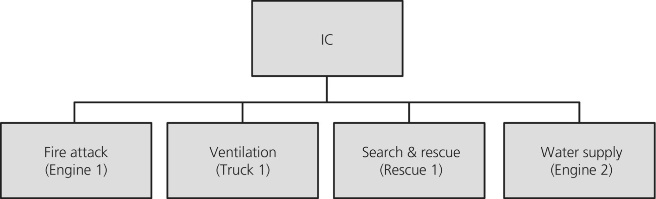
Figure 26.1 Small structure ICS. ICS for small structure fire requiring only four working crews.
In most circumstances, one individual is designated and recognized as the IC. It is clearly acknowledged, however, that there are instances in which multiple agencies (e.g. fire, EMS, law enforcement, public health) or multiple jurisdictions (e.g. adjacent towns, counties, states, federal government) have legitimate claims on command authority. Under these circumstances, a “unified command” is instituted with senior representatives of each stakeholder agency or government present in the command post who serve as the IC for their jurisdiction or agency. The unified command speaks with one voice as the IC for the situation, and any differences in priorities or tactics are worked out among the individual ICs that make up the unified command. This maintains unity of command, because each responder reports to a single supervisor, but it also maintains a pathway of expertise. For example, a fire department IC in a unified command structure does not tell the police responders how best to accomplish pure law enforcement functions. Instead, the fire IC discusses the best course of action with the police IC, and after agreeing on overall priorities and strategies, the police IC issues orders to the police responders that help fulfill the priorities and objectives set forth by the unified command. In complex, multijurisdictional incidents, the unified command not only generates the incident action plan (IAP), but also must agree on a single operations section chief who will be responsible for executing the IAP. When feasible, the component members of a unified command should be colocated in a single command post in order to facilitate this collaboration and to ensure that the various ICs involved are not duplicating or contradicting each other’s efforts in the response to the incident.
In its simplest form, the ICS may comprise only an IC directly supervising a handful of personnel assigned to diverse tasks. For example, the IC at a structure fire involving a single-family dwelling would initially need crews for fire attack, search and rescue, water supply, and ventilation. The most expedient way to assign personnel to these tasks is by designating the appropriate fire apparatus crews to those functions. The ICS organizational chart would then be described by Figure 26.1, where the IC delineates four tasks, and one “resource” representing an identifiable crew is assigned to each task.
As shown in Figure 26.2, in emergency management practice, there should be an orderly transfer of command when discrete phases of a response are completed. In some cases, this may involve termination of response activities and transition to recovery, and/or law enforcement investigations. Additionally, extended responses occurring over long periods of time, such as a public health response to a pandemic, require orderly change of command at periodic intervals to allow for responder rest and recovery.
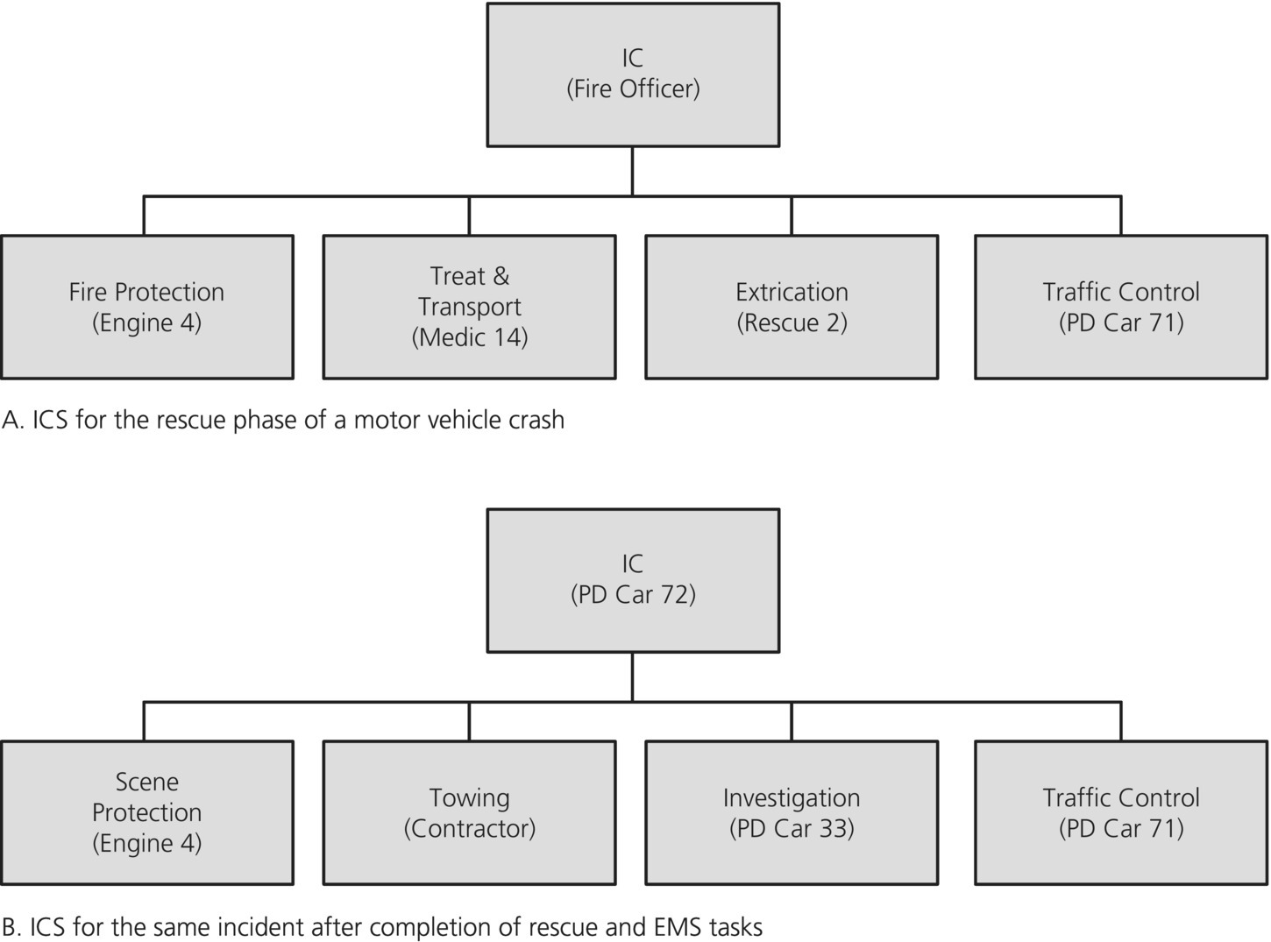
igure 26.2 Incident command transition. Transition of incident command during phases (A and B) of a single incident.
Methods for orderly transfer of command are prescribed in ICS, and are routinely used in fire control operations when command is passed from a company-level officer to a staff officer as the incident grows in size or complexity. It is important to point out that purely administrative fire chiefs or commissioners rarely assume command of an incident, as they frequently are not the most experienced operational personnel available. This separation of normal civil authority and incident command is another hallmark of ICS.
Returning to the example of the response to a structure fire, multiple fire attack crews and a water shuttle system may be necessary to extinguish the blaze. In that case, fire attack and water supply officers might be appointed. As shown in Figure 26.3, the officers of Engines 1, 5, 7, and 9 would report to the fire attack officer, while Engine 2 and the two tankers, one from an adjacent town providing mutual aid, would report to the water supply officer.
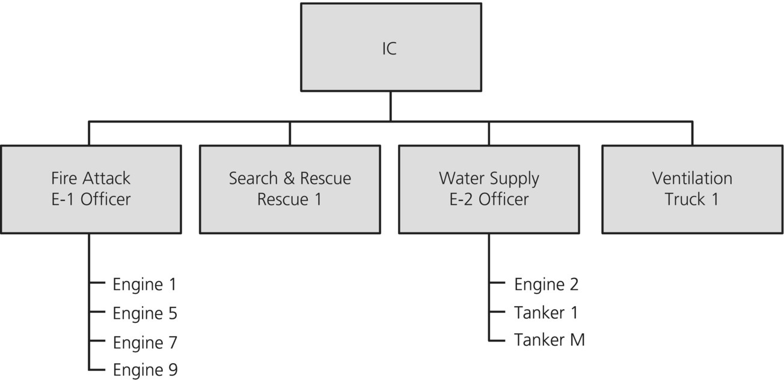
Figure 26.3 Control and unity. Maintaining span of control and unity of command through appointment of group or division officers.

Without this new layer, the IC would exceed the prescribed span of control limits by having direct responsibility for the crews of the seven additional services. The IC retains the prerogative of further expanding the incident management team using the following options.

Sections are organizational levels with responsibility for a major functional area of the incident (e.g. operations, planning, logistics, finance/administration). The person in charge is called a chief (i.e. logistics section chief, etc.).
Branches are used when the number of divisions or groups exceeds the recommended span of control (e.g. EMS branch, rescue branch, etc.). A branch is led by a director.
Divisions are used to divide an incident or facility geographically (e.g. first floor). A division is led by a supervisor.
Groups are established to divide the incident management structure into functional areas of operation. They are composed of resources that have been assembled to perform a special function, not necessarily within a single geographic division. A group is led by a supervisor.
Units are organizational elements that each have functional responsibility for a specific incident planning, operations, logistics, or finance/administration activity (e.g. situation unit, supply unit).
Single resources are defined as an individual or piece or equipment with its personnel complement (e.g. engine company or police officer) or a crew or team of individuals with an identified supervisor.
A task force is a combination of mixed resources (e.g. four engine companies, four police officers, and a public health epidemiologist) with a common communications capability and headed by a task force leader.
A strike team is a set number of similar resources (e.g. four engine companies) with a common communications capability who operate under the command of a strike team leader.
Adoption of a standardized lexicon that distinguishes assignment-specific working groups from task-oriented supervisory groups and personnel locations in horizontal versus vertical planes facilitates effective communication among people who do not work together on a daily basis. Hence, terms such as unit, group, crew, division, branch, or sector may be roughly synonymous in ordinary usage, but are unambiguous in an ICS (Figure 26.4). For example, while the “medical branch” and the “medical unit” seem like they would serve similar functions based on terminology, in the regimented vocabulary of ICS, they denote vastly different functions. The medical branch would be subordinate to the operations section, and would manage the operational medical resources responding to and mitigating the situation (e.g. EMS group, treatment group), while the medical unit would have specific responsibility for providing medical support to the responders themselves, and would fall under the logistics section. Likewise, standardized conventions are observed in diagramming organizational charts outlining the supervisory levels between the individual company assigned to a discrete task and the IC. These conventions allow for interoperability and clarity of roles in an incident spanning agencies and jurisdictions. These include conforming to the principles of unity of command and span of control as described above. Intermediate supervisors are not inserted into the scheme unless the working resources exceed an IC’s or other supervisor’s span of control.
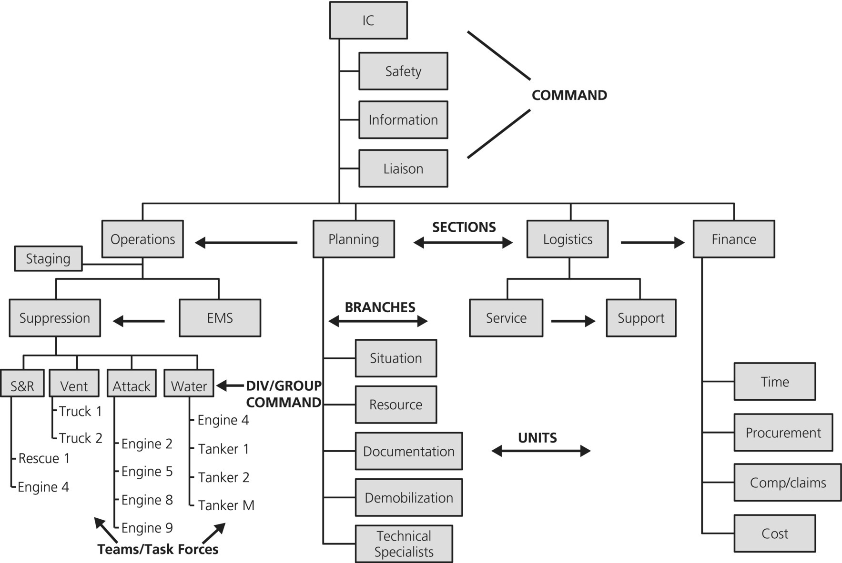
Figure 26.4 Large-scale event chart. Organizational chart for a large-scale event involving fire suppression, rescue, and medical care of civilian casualties. Standard terms for levels of management are shown in bold.
Situational awareness information passed from the working crews though the chain of command and instructions from the IC and supervisors to the crews are tightly circumscribed according to the principles of unity of command and span of control. This eliminates supervisor information overload and ambiguity or reporting relationships for working crews. It is important to understand that these constraints apply only to vertical transmission of information, and not to horizontal communications. Clearly, information sharing among crews and among supervisory staff at the same level within a branch or section may be critical to safe and effective field operations.
Three staff positions generally assigned to individuals at large or complex emergency incidents are considered to be an inherent part of the command function, and are not included in the IC’s span of control constraints: safety officer, pubic information officer (PIO), and liaison officer. As the titles imply, the three are responsible, respectively, for scene and overall safety for both responders and civilians threatened by the incident, interacting with media personnel, and providing a conduit for two-way information between the IC and representatives of other responding agencies. These positions make up the IC’s “command staff.” One of the key advantages of establishing an incident command center and having individuals designated to these tasks has been better control and better quality of information released to the public. Another has been improved interagency communications, which were previously stymied by incompatible radio frequencies, inconsistent terminology, and turf skirmishes if not overt wars.
The safety officer is responsible for the overall safety of everyone at the scene of the incident, including responders, civilians and victims already involved with the incident, and bystanders and others at risk of being affected as the incident and response progress. The safety officer works within the chain of command (reporting to the IC) to keep all responders to an incident safe. At the same time, the safety officer maintains an important emergency authority to instantly issue orders to cease any activity that is deemed unsafe. This emergency authority is the only allowable exception to the unity of command concept, in that it allows someone other than a direct supervisor to issue orders to a responder, though it only allows a “stop” order in cases of a potential hazard.
A joint information center may be created to address the broad range of risk communications and public education issues. The center is usually housed at a suitable location near the incident or the local emergency operations center (LEOC), and is composed of PIOs from all responding partners. The PIOs use the operating procedures defined in a joint information system plan to draft information for IC approval that is given to the media and public in a timely and effective manner.
Liaison officers serve as links between the incident command post and other external partners such as the LEOC. In their role, they share information with various parties and also make requests for various types of assistance as needed.
To manage large, complex, or protracted emergencies, the working resources under an IC are typically organized into four sections: operations, planning, logistics, and finance/administration. The officers assigned to those sections report directly to the IC. The operations officer is responsible for tactical decisions and for maintaining situational awareness through reports from the work crews. In an incident involving fire in an occupied commercial structure with known chemical hazards on site, the operations chief might need to staff branch positions to supervise multiple EMS crews, fire suppression crews, evacuation crews, and hazardous materials crews. Meanwhile, the fire suppression branch might resemble the full ICS depicted in Figures 26.1 or 26.2, with multiple crew chiefs reporting to the branch officer. In any public health emergency incident, much of the operations section’s responsibility would involve identification of a broad spectrum of medical tasks to be accomplished, and assigning personnel or units to these functions. If the emergency has resulted from a weapon of mass destruction or occurs under a threat situation, the operations section will have both law enforcement and medical components. The staging manager who is responsible for coordinating resources awaiting an assignment also reports to the operations section chief.
The remaining three ICS sections would operate in a public health emergency in the same general way as in any complex, multiagency, public threat incident. The planning section continually assesses the situational aspects of the incident and provides predictions of likely scenarios. Similarly, this section monitors resources as they are committed to the incident and estimates both immediate and long-term requirements. The planning section has the primary responsibility of drafting an IAP for IC approval. The IAP outlines the control and strategic objectives as well as the anticipated resource requirements for each operational period. It is also used as part of the initial briefing given to each oncoming shift of command personnel. The planning section typically includes all technical specialists who may be needed to advise command personnel. Examples might be structural engineers at a structure collapse or toxicologists at hazardous materials incidents. Responsibility for recording and maintaining documents related to incident operations rests within the planning section, as does planning for logical, sequential demobilization of resources once the incident is under control. The documents used during a response include the appropriate FEMA forms as well as agency- or institution-specific records being completed manually or using computers. The planning section may, at the direction of the IC, play a leading role in drafting the after-action report once the incident response is complete.
The logistics section frequently comprises separate service and support branches. The service branch provides interoperable communications capabilities as well as food, hydration, and medical support for emergency responders. Equipment, including repair capabilities and fuel, supplies, access to fixed facilities, sanitary requirements, and maintenance of the command post are all under the purview of the logistics section’s support branch. Resources are acquired using existing mutual aid agreements as well as routine or emergency vendor agreements. The LEOC will normally be activated for major incidents and may also assist with resource management and other response-related issues in support of the IC.
The finance section is staffed when significant procurement capabilities are required to accomplish mission goals. This section also keeps records on personnel involved and periods worked. Such records are essential when responder injuries or death may result in future compensation claims, as well as remuneration of salaried personnel working at an incident. In addition, a cost unit is frequently established for managing budgets and projecting cost estimates. It should be headed by a government official with authority to spend funds and sign contracts.
For an incident to be managed effectively, those in charge must be familiar with and have ready access to their agency and/or community emergency operations plan and have taken requisite ICS training. In 2004, the NIMS Integration Center (now called the NIMS Integration Division, part of the Department of Homeland Security) outlined a series of required educational programs for local, state, and federal officials. Similar requirements were outlined for health care facilities in 2006. The four primary courses (IS 100 and 200, Incident Command Principles; IS 700, NIMS; and IS 800, National Response Plan, now called National Response Framework) are available online and in classrooms from the Emergency Management Institute; we recommend that all EMS physicians complete this training. Additionally, the NIMS Integration Division has established a process of precredentialing and “resource typing” to set a national standard in order to streamline and standardize the request for and application of resources in an incident in which the NIMS is applied. Precredentialing is a process by which certain assets are screened and their qualifications verified ahead of time in order to avoid the process of issuing emergency credentials upon activation of a resource, delaying their actual response to the incident. This allows much more rapid interoperability of a variety of assets across jurisdictional, geographical, or agency boundaries. Resource typing creates a standardized catalogue of resources from which an IC can choose, and ensures that the responding unit or resource is capable of the task intended for it. All resources, from fixed-wing air ambulances to swiftwater search and rescue teams to emergency floodlights, are broken into four “types” based on capability, staffing, and level of support required. This allows an IC to request the unit that will be best suited to the mission at hand.

Conclusion
Experience has repeatedly shown the importance of an ICS being successfully applied to meet the response challenges posed by any type of emergency incident regardless of type or size. The NIMS is the ICS now in use throughout the United States. The principles it contains were taken from the best management practices from public safety institutions, the military, and business world.
The NIMS contains principles that recognize emergencies will generate essential tasks that do not exist in the routine job description of any one office, and decisive authority must be given to key personnel, who in some cases may not be the highest-ranking officials within an organization. In ICS, experience and expertise should take precedence over rank.
Specific positions may be filled by the IC based on situational assessments of the need and availability of qualified people to assume such roles. These positions have standard titles, responsibilities, and reporting relationships.
For command personnel to be successful, prior training and planning and regular participation in exercises or responses are required. In an effort to promote standardization, improved performance, and readiness, the federal government has outlined a number of NIMS courses for those who will be assigned to command roles at the local, state, and federal level. Some can be completed online, while others are offered only in a classroom setting.
Craig DeAtley was a co-author of the first edition of this chapter; many of his contributions remain in this revision, and are acknowledged.

References
- 1 Merriam-Webster’s Collegiate Dictionary, 10th edn. Springfield, MA: Merriam-Webster, 1994.
- 2 Adler PS, Borys B. Two types of bureaucracy: enabling and coercive. Admin Sci Q 1996;41:61–89.
- 3 Adler PS, Goldoftas B, Levine DI. Flexibility versus efficiency? A case study of model changeovers in the Toyota production system. Org Sci1999;10(1):43–68.
- 4 Roberts KH. Some characteristics of high reliability organizations. Org Sci 1990;1:160–77.
- 5 Roberts KH, Stout SK, Halpern JJ. Decision dynamics in two high reliability military organizations. Manag Sci 1994;40:614–24.
- 6 Grabowski M, Roberts KH. Risk mitigation in virtual organizations. Org Sci 1999;10(6):704–21.
- 7 Bigley GA, Roberts KH. The incident command system: high-reliability organizing for complex and volatile task environments. Acad Manag J2001;44(6):1281–99.
- 8 Department of Homeland Security. Homeland Security Presidential Directive 5. Washington, DC: Department of Homeland Security, 2003.
- 9 Department of Homeland Security. National Incident Management Systems (NIMS). FIRESCOPE. Field Operations Guide, ICS 420-1. Available at: www.usfa.fema.gov/downloads/pdf/publications/field_operations_guide.pdf
- 10 National Wildfire Coordinating Group. A History of the Incident Command System. Incident Command System (ICS) National Training Curriculum, October 1994. Available at: www.nwcg.gov
- 11 Brunacini AV. Fire Command. Quincy, MA: NFPA Publications, 1983.
- 12 Morris GP. Incident command: past, present, future, and merger. Int Soc Fire Service Instructors Voice 1992;21:13–14.
- 13 National Fire Protection Agency. NFPA Standard 1500: Fire Department Occupational Safety and Health Program. Standard 1561: Emergency Services Incident Management System. Standard 472: Competence of Responders to Hazardous Materials/Weapons of Mass Destruction Incidents. Standard 473: Competencies for Medical Responders to Hazardous Materials/Weapons of Mass Destruction Incidents. Quincy, MA: National Fire Protection Agency.
- 14 Code of Federal Regulations. Part 1910, Occupational Safety and Health Standards. Subpart 120, Hazardous Waste Operations and Emergency Response. 29 CFR 1910.120.
- 15 Code of Federal Regulations. Part 1910, Occupational Safety and Health Standards. Subpart 134, Respiratory Protection. 29 CFR 1910.134.
- 16 Morris GP. Medical incident command. J Emerg Med Serv 1982;7:24–37.
- 17 Federal Emergency Management Agency. Incident command system for emergency medical services. In: National Fire Academy Student Manual. Washington, DC: Federal Emergency Management Agency, 1997.
- 18 Londorf D. Hospital application of the incident management system. Prehosp Disaster Med 1995;10:184–8.
- 19 California Emergency Medical Services Authority. Hospital Incident Command System (HICS). Available at: www.emsa.ca.gov/disaster_medical_services_division_hospital_incident_command_system_hics
- 20 Federal Emergency Management Agency. Fire Department Response to Biological Threat at B’nai B’rith Headquarters, Washington DC. Major Fires Investigation Project, Report 114. Washington, DC: US Fire Administration, 1997.
- 21 Inglesby T, Grossman R, O’Toole TA. Plague on your city: observations from TOPOFF. BioDefense Q 2000;2:1–10.
- 22 Hoffman RE, Norton JE. Lessons learned from full-scale bioterrorism exercise. Emerg Infect Dis 2000;6:652–3.

